How food can help prevent chronic inflammation
Written by: Michele Meyer | Updated: May 28, 2019
6
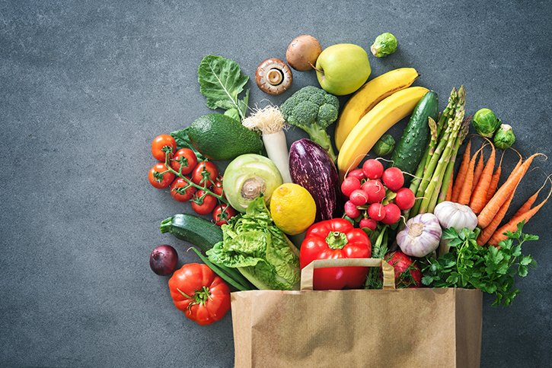(Photo by Getty Images)
Inflammation in the body can be a good thing, since it triggers an immune response that promotes the healing process and protects against infection and injury. Yet inflammation may stay active even after the initial threat has been eliminated. This chronic, or persistent, low-grade inflammation can linger for months or years and is linked to diseases such as rheumatoid arthritis, heart disease, Type 2 diabetes, cancer, and COPD (chronic pulmonary obstructive disease).
The best prescriptions for treating chronic inflammation lie in not only pharmacies but our kitchens, says Wesley McWhorter, MS, RD, LD, CSCS, dietitian and chef with the Nourish Program at The University of Texas Health Science Center at Houston (UTHealth) School of Public Health.
“We need to increase positive things on the plate and decrease negative things,” McWhorter says. “But the goal isn’t perfection. We’re not even close to the middle ground.”
The key to fighting chronic inflammation with nutrition is to decrease foods high in added sugar and starches, and increase your intake of food groups such as vegetables, fruits, whole grains, and omega-3 fatty acids, say McWhorter and fellow Nourish Program dietitian Shannon Weston, MPH, RDN, LD, CDE.
Let your plate lead you to a healthier diet: Strive for one-half of your plate to be veggies (raw and cooked) and fruits in a variety of hues; one-fourth plate of whole grains; and one-fourth proteins – ideally at every meal – as recommended by the U.S. Department of Agriculture.

Vegetables
Yes, you should read labels. However, the best anti-inflammatory foods don’t have any.
“All vegetables are wonderful for you,” McWhorter says. “That includes nightshade veggies, such as eggplant, tomatoes, and bell peppers, despite their erroneous rep as pro-inflammatory agents.”
What to do with them: To get the texture of French fries – without the risk – roast vegetables such as asparagus, squash, cauliflower, carrots, Brussels sprouts, or sweet potatoes. Preheat your oven to 375 degrees. All vegetables need to be cut to the same size for even cooking. Coat the vegetables evenly with olive oil and season with 2 tablespoons of herbs.
Place on parchment paper on a baking sheet and roast 15 to 30 minutes until tender and crispy, flipping halfway through.

Fruit
All fruits in their whole form are great for reducing chronic inflammation. Red and purple fruit, including strawberries, raspberries, blueberries, blackberries, and cherries, are especially high in anthocyanins and other antioxidants.
Fruit contains natural sugar in the form of fructose, or fruit sugar, but also contains fiber that helps slow down the absorption of sugar. Fruits in their whole form are not processed; however, canned fruit, juices, smoothies, and other items that contain fruit can have added sugars, as sweeteners or flavor enhancers.
On average, we consume 71 grams of added sugar each day, and we should eat fewer than 50 grams daily (10 percent of a 2,000-calorie diet). Even better would be to consume no added sugar at all.
“There is no benefit to added sugar,” McWhorter says.
Where to add fruit: Add to water, oatmeal, salads, and other dishes – and eat as dessert or snacks. Limit artificial sweeteners, agave, and honey, which are still considered added sugars. Watch the portion sizes for dried fruit because it is a concentrated form of fruit sugar and often contains added sugar.

Whole grains
Whole grains in oatmeal, brown rice, whole-wheat bread, quinoa, and other unrefined grains tend to be higher in inflammation-fighting fiber than white forms, which have been processed or had their shells removed.
“To identify if an item is whole grain, look at the listing of ingredients on the label,” Weston says. “If the first ingredient listed contains the word “whole,” it is likely that the product is predominately whole grain.”
Many grains are gluten-free, but there is no need to avoid gluten unless you have been diagnosed with celiac disease, Weston says. Celiac disease is a disorder in which eating gluten triggers an immune response in the body, causing chronic inflammation and damage to the small intestine.
Eat whole grains instead of: White bread, white rice, crackers, white-flour breaded meat, and other “refined” starches.

Salmon, tuna, and fish
You don’t have to become a vegan, vegetarian, or even pescatarian. At least twice weekly, dive into cold-water, fatty fish rather than fatty meats.
Salmon, tuna, trout, mackerel, and sardines are steeped in omega-3 fatty acids, which reduce triglycerides and inflammation, Weston says.
How to prepare: Choose a 4-5 ounce filet of salmon, trout, or snapper per person. Preheat broiler. Blend 2 tablespoons of thyme, oregano, or other herbs with 1 tablespoon of canola oil and the finely chopped zest of one lemon. Place fish on parchment-lined baking sheet. Top with seasoning and broil 6-8 minutes to an internal temperature of 135 degrees Fahrenheit (usually checked with an instant read thermometer).

Legumes, nuts, and seeds
Legumes – including lentils, black-eyed peas, and garbanzo, black, pinto, navy, and kidney beans – are great sources of fiber and protein.
Similarly, walnuts, almonds, pistachios, pine nuts, and pumpkin, sunflower, or sesame seeds pump up the protein. They also contain healthy omega-3 fatty acids.
How to use: Look for no- or low-salt canned beans and toss them into soup, stew, salads, rice, and tacos, McWhorter says. Using the bean-based hummus instead of mayonnaise cuts fat and boosts fiber and protein. Nuts and seeds are not only great additions to salads and stews, but make great snacks. Making a simple “trail mix” with popcorn, nuts, and some dried fruit is an easy, portable snack.

Olive and monosaturated oils
Seek olive, canola, and other monosaturated oils. Extra-virgin olive oil, in particular, curbs pro-inflammatory enzymes as well as cartilage damage. Canola, peanut, and other plant-based oils are anti-inflammatory, unless used for deep-frying. In the case of deep-frying, McWhorter says, oils that are not filtered after use retain food particles that break down. Repetitive use of oils without cleaning leads to a loss of “antioxidant power.”
Substitute these oils for: Margarine and tropical, hydrogenated, or partially hydrogenated oils, including safflower, corn, and sunflower oils.
What to do: Ditch greasy, deep-fried, and highly processed foods. Roast instead.

