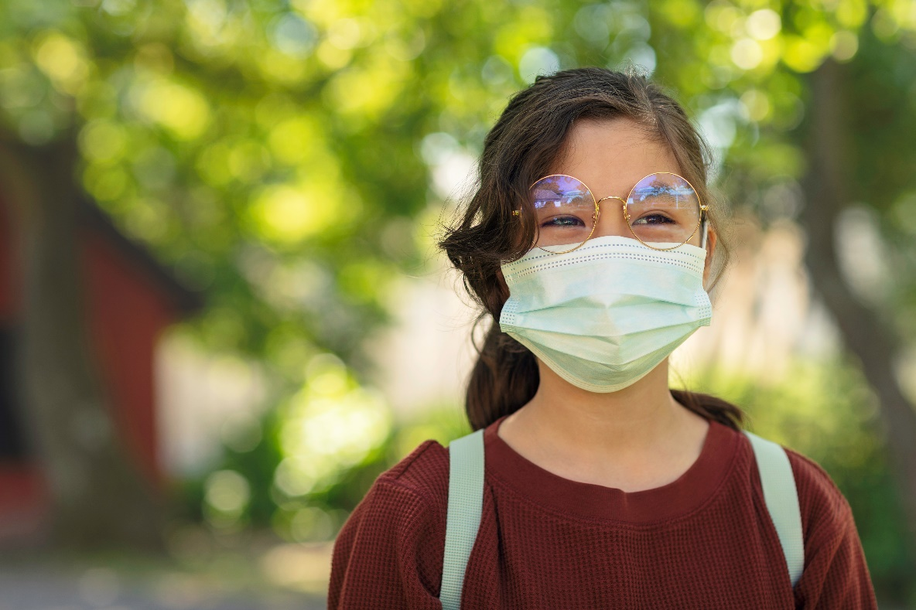

Safety Tips for Kids During COVID-19
These are scary times—especially if you face sending your unvaccinated children back to in-person school or daycare while COVID-19’s Delta variant lurks.
You’ll do what’s best for your children. But what might that be?
“Children who went back to school in person were much happier,” says Gaile Vitug, DO, pediatrician with Children’s Memorial Hermann Pediatrics Sugar Land. “Many children struggled to flourish academically, physically or mentally during at-home learning.”
Studies confirm her findings that while on-campus education excels, on-screen education flunked in the goal of keeping kids performing at their grade level.
With schools reopening, how can you protect your children when only kids 12 and up can get vaccinated?
First, rely on the preventive measures we used before vaccines: masks, social distancing, frequent handwashing and isolating ill kids at home.
Easier said than done? Dr. Vitug shows the way to ensure your kids follow the rules:
Talk it out. Explain to your kids why masks protect us and our community. “Kids are really smart and resilient, and they’ll understand,” she says.
Use very simple vocabulary for tykes under age 3. They understand if you tell them the family is doing this to stay safe and healthy, just like when you wear seatbelts in cars.
With older children, you can talk about germs, COVID-19 and current guidelines from the U.S. Centers for Disease Control and Prevention (CDC). Also, explain to them that these measures will let them be with their friends, Dr. Vitug adds.
Get children involved. Let them choose their mask or help to make or personalize one. “They’ll be more enthusiastic and prouder to wear their masks,” says Dr. Vitug.
Practice makes perfect. Familiarize tots with masks by having them wear one at home for short periods of times so they become accustomed to them.
You also can put masks on some of their favorite stuffed toys and dolls. When the family goes on an excursion, wear masks and bring the masked toy.
Be good role models. Wear face coverings when you go out or enter indoor spaces other than your home. Show how you make them snug on yourself—and them. “Also, if our older siblings are doing it, younger ones are more likely to do it,” says Dr. Vitug.
Make a point of social distancing and noting floor markings when you see them. Also wash hands with soap frequently and thoroughly, counting to 20 or singing the happy birthday song twice. You might even take turns checking each other’s temperatures.
Picture it. Tell them stories to explain why your family is playing it safe. If you’re at a loss for the right words, online books for different ages can help. Dr. Vitug recommends picture books that explain COVID-19 precautions in simple terms children will understand.
Be open about peer pressure. Texas public schools cannot mandate masks or vaccinations, but Harris County strongly encourages both. “If children are not seeing other kids wearing masks, they won’t feel comfortable wearing one and that’s why it’s our job to make them feel secure,” Dr. Vitug says.
Remind them that true superheroes wear them and show your kids pictures of others in masks. You also can bring up the adage: “If everyone jumped off a cliff, would you?”
Make it a game. Just as you might entertain kids by looking for other state license plates, you can see who first notices people with face coverings. You might use tape and mark off social distances between dining room chairs or use pillows on sofas to separate family members.
Pack something extra in their lunchbox. Sanitizing towelettes and gel mini-pumps will help them remember to clean their hands before snacks or taking off masks. They can ask nearby adults for special hand cleaners.
Also remind them to keep their hands out of their mouths and to cover their mouth and nose with a tissue when coughing or sneezing. Throw used tissues in the trash. And if they don’t have tissues, they should cough or sneeze into their elbow.
Do the same at home—and everywhere.
Compromise if your child has multiple health issues. Talk with teachers, daycare and your pediatrician about concerns and review their protocols if a sick child comes to class.
“The scariest thing is the unknown,” Dr. Vitug says.
If your child is at high risk, or suffering from complications recovering from COVID-19, you might adjust their schedule so they’re in school part-time. “Ultimately, you want your children to be happy and successful,” she says.
Be open to change. “We’re in the midst of a pandemic, which can change day to day or week to week. We need to learn and adjust,” Dr. Vitug says.
Let your children guide you, she says. “They may adjust to their new normal more quickly than you do.” Learn more →

