Brands That Bought Into Prime-Time Diversity
Michele Meyer
09-15-2016
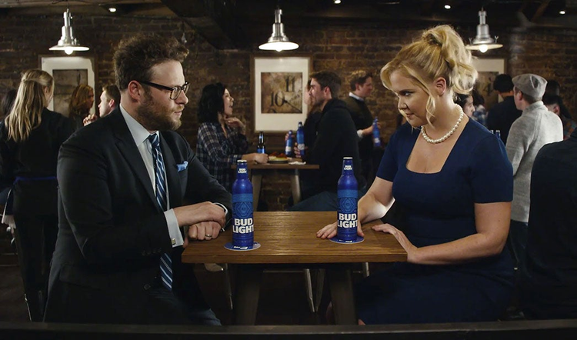

Marketers take risks running ads during prime-time shows that target specific ethnic groups and have the potential to offend.
Marketers take risks running ads during prime-time shows that target specific ethnic groups and have the potential to offend. Think “Black-ish” (African Americans), “Jane the Virgin” and “Devious Maids” (Latinos), “Transparent” (transgenders), “Fresh Off the Boat” (Asians), “The Goldbergs” (Jews), and “The Real O’Neals” (Catholics).
But risks can yield rewards.
Like predecessors “Modern Family,” “The Jeffersons,” “Moving on Up,” and “All in the Family,” such sitcoms can be controversial yet successful. Indeed, all seven are back this fall.
Viewers increasingly support the shows’ pro-diversity message—and it’s not just Millennials who are more open to different cultures and sensibilities: Fifty-five percent of Americans support gay marriage, in contrast to 15 years ago when 57 percent strongly opposed it, according to Pew Research Center.
Besides, minorities are becoming the majority: More than half of children under age 5 are non-Caucasian, reports the U.S. Census (PDF). So are 37.9% of Americans, up from 30% 15 years ago.
Thus, the line between deft and tone-deaf is ever-moving. Inclusion is becoming the new norm, though that certainly doesn’t mean advertising during such shows is right for every brand.
But the following five advertisers who took a chance on these sitcoms and gained handsomely.
Honda: “The Dreamer”
In “The Dreamer,” a 2016 Honda Civic commercial, an engineer envisions his creation taking a thrill-ride no theme park could match, accompanied by Empire of the Sun’s “Walking on a Dream.” A road materializes, twists upside down, and spins 360 degrees before shooting past waterfalls, a windmill, and a hot air-balloon to land on a rainbow. As the auto races into a showroom, a voice-over announces, “Direct from our imagination: the all-new Civic.”
Besides standing out among the 500-plus carmaker ads produced yearly, “The Dreamer is entertaining and inventive–something you want to identify with, whether you’re 18 or in your 60s,” said Tom Peyton, American Honda’s assistant vice president of marketing.
As America’s top-selling compact car, the Civic’s placement on prime-time comedies with a multiethnic slant was key, Peyton said.
“As a generally conservative company, we avoid violent or off-color content,” he said. “We targeted a variety of ethnicities but also a broad audience.”
Even so, “The Dreamer’s” acceleration to the top of internal metric charts since its debut last December exceeded the carmaker’s own dreams. Not only does the commercial rank among the brand’s all-time top five Civic ads, according to in-house metrics and nearly 3 million YouTube views, but “it’s one of our most successful ads, period,” Peyton said.
The Dreamer even drove its 7-year-old song to an unexpected destination: the Billboard 100 chart, which it entered for the first time, rising to 62. It also reaped 62.6 million views on YouTube.
“In the first week alone, it blew up on iTunes with 30,000 downloads and hit No. 5 on Shazam’s list of most Shazamed tunes,” Peyton said.
Bud Light: “Food Truck,” “The Pay Gap Is Real,” “Weddings,” “Bud Light Party”
No social issue eludes Bud Light, which has tackled cultural diversity, gay marriage, and equal pay as part of its “Bud Light Party” election-year campaign.
“We’re about bringing everyone together,” said Alex Lambrecht, the brand’s vice president of marketing at Anheuser-Busch. “We’re leveraging timely cultural moments in a lighthearted way.”
Thus, the brewery hired “down-to-earth” comedians Amy Schumer and Seth Rogen (along with Mixed Martial Arts fighter Ronda Rousey and actors Michael Peña and Paul Rudd) to address hot-button social issues.
“The ads are funny, and the casting of Schumer and Rogen makes a huge difference: They’re Millennial-friendly and can say almost anything and get away with it,” said Andrew Speyer, executive planning director at Miami ad agency The Community. “I would not expect Bud Light to have this conversation, but they did it masterfully, and it feels honest.”
That’s because it is. Anheuser-Busch’s first pro-LGBT ad ran in 1995, and the brewery financially supports GLAAD. “Inclusivity is part of our DNA, so there are no risks,” Lambrecht said. “If you’re doing what consumers expect from you, you have the credibility and permission to ‘go there.’”
This also has enabled ads to bubble over with as many as 16 million YouTube views per commercial and up to 92% “highest positive sentiment” in-house data rating, Lambrecht said.
“Ours is a very strong message that the vast portion of the population agrees with,” he added.
Or, to quote Rogen: “America has seen the light, and there’s a Bud in front of it.”
Reliant: “All Sorts, “All Sorts 2”
What could be more Texan than native actor Matthew McConaughey’s drawl set against harmonica-rich country blues?
Try a parade of Texans of many ethnicities and professions, including a fire-breather, astronaut, belly-dancer, basket-weaver, jockey, dog-walker, violinist, painter and bartender.
“There are millions of Texans, and the one thing we all have in common is we’re unique,” McConaughey said.
Sprinkle in former Houston Rockets center Dwight Howard and Fluff Bake Bar owner Rebecca Masson, and current and potential customers are riveted to commercials for–yawn–an electricity provider.
Not only do Reliant Energy’s 30-second commercials spark interest, but they celebrate the state’s diversity while announcing the company’s willingness to tailor service to individual homeowner’s needs.
As McConaughey concluded, “After all, Texas, we’re just like you: totally one of a kind. Reliant.”
The ads air in English and Spanish during prime time , live sportscasts, and video-on-demand to “reach as many people as possible in our targeted audiences,” said Tom Hughes, head of retail marketing and advertising for electric firms Reliant and NRG.
Two versions of “All Sorts” were filmed at the same time last year and showed consecutively to thwart consumer fatigue, he said: “We cast real people who live in Texas and filmed them here, showing some in their actual profession.”
Extensive research determined the ads would resonate as intended. Web traffic, sales, and retention rose, “exceeding our success metrics of awareness, consideration, purchase, likeability, and willingness to recommend,” Hughes said.
As their spokesperson would say, “Alright, alright, alright!”

