5 Easy Ways to Handle Holiday Crowds

Follow these tips to ensure you don't lose holiday shoppers or sales.
BY MICHELE MEYER • NOV 25, 2013
Opinions expressed by Entrepreneur contributors are their own.
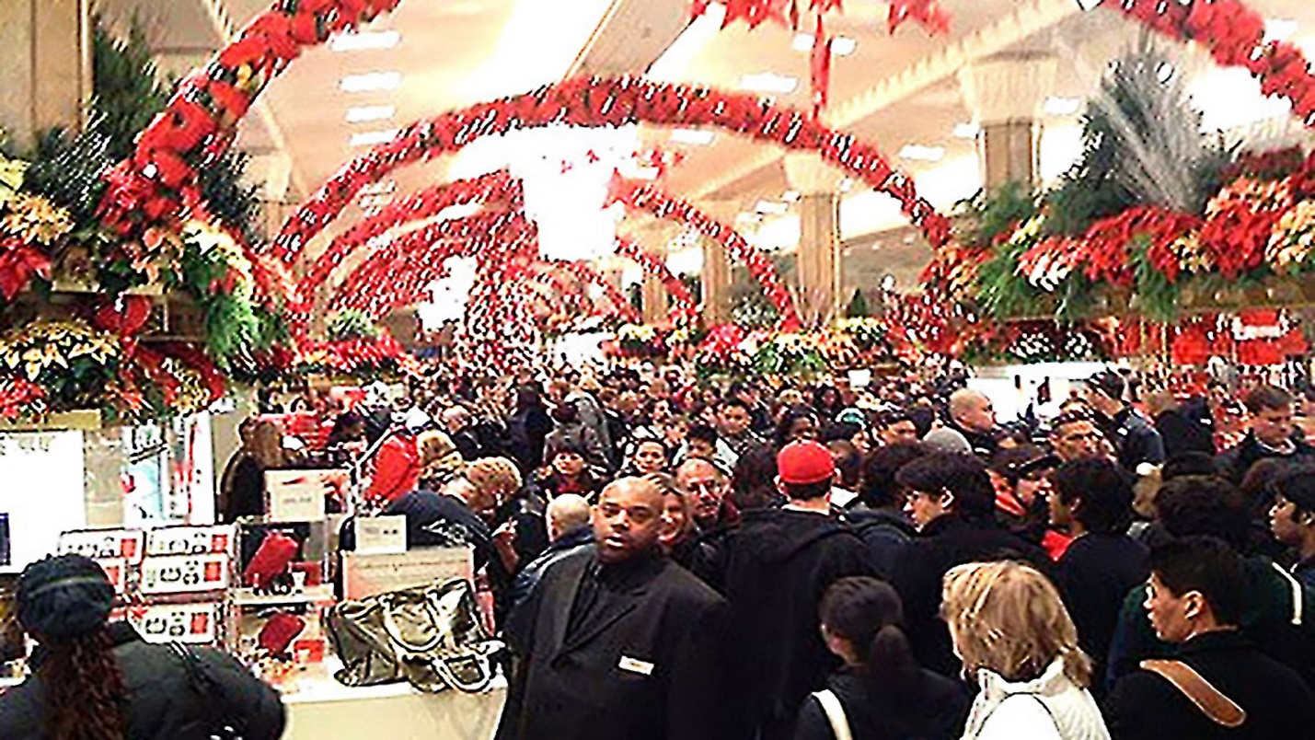
4.bp.blogspot.com
During the holidays, your customers are as primed to spend as they'll ever be, with retailers reaping up to 40 percent of their annual sales from November through December, according to the National Retail Federation.
But crowds and mismanaged stores can still keep shoppers away, a situation few stores can afford. "The mistake that cost you $10 in June is going to cost you $50 to $100 at the holidays," says Phil Rubin, chief executive officer at rDialogue, a loyalty marketing firm in Atlanta.
To keep shoppers, and not repel them, you need to be savvy about how buyers think during the busy holiday season. Here are five tips from retail loyalty strategists that will help you ensure sales success.
1. Keep long check-out lines in check. Snaking lines of snarling shoppers may make prospects flee your store. Worse, they may abandon carts of merchandise inaccessible to others. "The more waiting customers, the faster you must be," Rubin says. According to our experts, if a line is moving quickly, they are less likely to leave it. At high-traffic times – especially 2-4 p.m. Saturdays -- every register should be operating, with a traffic director funneling a roped-off queue to open cashiers. For a good rule of thumb, some savvy shops will open a new register when there are 3 people in the queue. As one person rings sales, another should bag items.
As a special reward, hand out free bottled water for tired shoppers at the register. "That costs you 15 cents and is emotionally satisfying," says Rubin, "versus a coupon which only hurts you since they're already committed to spending."
#insert related here#
2. Keep staff helpful and informed. Admonish the hovering and replace the surly. If staffers don't know your wares, keep them at the register. Instruct the knowledgeable to work the floor, in easily identified uniforms or nametags, asking shoppers who they're buying for and at what price range. "These clerks are in triage mode," says Wendy Liebermann, retail strategist and chief executive officer of WSL in New York. "As in an emergency room, they're there to diagnose and get people the help they need as quickly as possible."
3. Be tidy. Avoid poor signage, crowded aisles and untidy fixtures and fitting rooms. An orderly store is vital for customers who are used to quick finds online. Periodically, walk your store as if you were a customer. Watch for messy dressing rooms and restrooms, as well as sloppy displays. Ensure aisle markers are visible from the entrance and that the aisles themselves are passable and angled to keep merchandise easily viewable. Make sure staff are polishing fixtures, refolding stock and monitoring restrooms throughout their shifts.
"Your goal is to be a sea of calm in the chaos of holidays," says Bob Phibbs, chief executive officer of The Retail Doctor in West Coxsackie, NY. "You don't want shoppers to be frustrated and give up."
4. Make purchases easy. When merchandise is inaccessible, it doesn't move. Keep as much stock on the floor as possible, replenishing constantly. Station clerks with keys near all locked cases and fixtures. Ensure lines for fitting rooms stay short. Make sale items accessible by keeping high-dollar door-busters in carts on the sales floor. "Nothing's worse than traveling to a store and learning they do not have what you wanted," says Jeffrey Inman, a University of Pittsburgh marketing professor. "Shoppers aren't likely to buy other items if their primary objective isn't achieved."
Give shoppers simple solutions to their gift-list problems. Near your store's front, create a section that addresses your customers' greatest holiday priorities first (gifts for spouses, children and close friends), and lesser needs second (gifts for teachers, hairdressers and acquaintances). Within each area, separate presents by price, under $25, $50 and $100.
5. Shopping feels like another chore. Give customers a reason to explore your store and enjoy the shopping experience. They're more likely to linger and succumb to their impulses if you entertain them. Play music, hire a strolling Santa, offer free cider or cookies, and set up an interactive display (anything from a moving train set in a shop window to runway videos showcasing your clothes). "You want to make the experience so compelling they don't want to leave," Rubin says.

Michele Meyer
Michele Meyer writes for DealNews.com, Departures, InStyle and Black Card Mag. She contributed to the trade’s Women’s Wear Daily for 11 years, Allure for eight and Lucky for one. Michele paid for college working as a department store manager, salesclerk and holiday staffer. In her free time, she hikes her friends’ garage sale profits by staging their merchandise.

